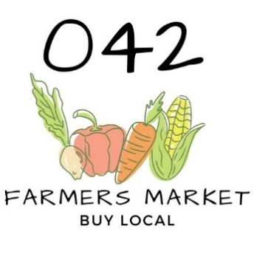
Vendor Application
FOR OFFICE USE ONLY
CATEGORY 2 VENDOR ONLY

SERVSAFE CERTIFICATION: _______
BUSINESS LICENSE: ______
LIABLILITY INSURANCE: ______
LABEL PHOTOS: ______

FOR OFFICE USE ONLY
NO. OF BOOTHS _______ ELECTRICITY _______
PRODUCTS ____________________________
MARKET DATE | PAYMENT TYPE | AMOUNT | DATE OF PAYMENT

Company Name: _______________________________ Contact Name: _____________________________
Address: ______________________________ City: __________________ State: ______ Zip: ______________
Phone: _____________________________ Email: ________________________________________________

Please provide a brief description of each of the items you wish to sell at the 042 Markets.
**No resale items allowed**
_____________________________ _____________________________ ___________________________
_____________________________ _____________________________ ___________________________
_____________________________ _____________________________ ___________________________
Number of 10’ x 12’ booth spaces requested per market date: □ ONE □ TWO □ THREE
$20 per market – Additional $10 rental per booth space (Limited to 2 additional spaces)

Will you need electricity? □ NO □ YES Purpose: ________________________________________________

Food Vendors, have you included a copy of your food permit and liability insurance? □ NO □YES
Note: Category 2 vendors without licensing will be identified as a cottage food operation and must submit a copy or photo of the required label.

Please check the dates that you wish to rent a booth. We accept checks and money orders (payable to The City of Brandon), as well as cash.
□ June 11th □ July 9th □ August 13th

Please refer to Farmers Market Requirements: https://www.mdac.ms.gov/bureaus-departments/farmers-market/permit-requirements/
Applicant shall be individually responsible for any loss, personal injury, deaths, and/or any other damage that may occur as a result of any act or omission of the applicant its servants, agents, and/or employees, and applicant acknowledges and agrees that for itself, its officers, directors, employees and associates, that is shall indemnify, defend, save and hold harmless Brandon Community Market , its servants, employees, agents, associates, and the City of Brandon, it’s officials, officers, employees, agents, and/or associates from any claim for damages, including attorneys' fees, suffered or incurred as a result of any act and/or omission by applicant, its servants, agents and/or employees.

DISCLAIMER:
It is the responsibility of the applicant to insure full compliance with all applicable federal and state laws and municipal ordinances and to pay all fees, taxes and other costs and expenses as applicable and to provide all required reports, notices or other documentation to the proper governing authority as and when due.
I have read the vendor guidelines and understand that failure to comply with any 042 Farmers Market policy will result in dismissal from the market.

Print Name: ______________________________ Signature: ___________________________ Date: ______

Mail application and photos to:
City of Brandon Attn: Carley Keyes P.O. Box 1539 Brandon, MS 39043

